# Making Alt Text Work

Each of the sample web pages below has a picture of a cat. Suggest alt text you could use for each image.

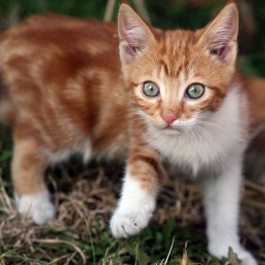The domestic cat (Felis catus or Felis silvestris catus) is a small, usually furry, domesticated, and carnivorous mammal. It is often called the housecat when kept as an indoor pet, or simply the cat when there is no need to distinguish it from other felids and felines. Cats are valued by humans for companionship and their ability to hunt vermin and household pests.

Cats are similar in anatomy to the other felids, with strong, flexible bodies, quick reflexes, sharp retractable claws…

## Sing Along!

Having a bad day? Feeling down? Sometimes you just feel like life is against you, and you are stuck in a bad situation. When that happens, I want you to remember the power of song! That’s right, a simple, cheerful song can improve your mood and give you the pep you need to keep going…

## Lords of the Housetops: Thirteen Cat Tales

Edited by Carl Van Vechten

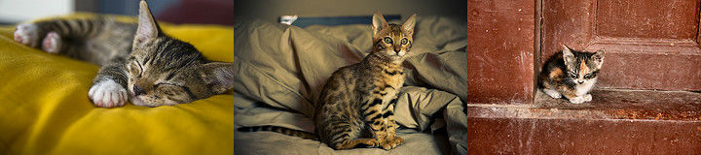

In the essay and especially in poetry the cat has become a favourite subject, but in fiction it must be admitted that he lags considerably…